
PREDICTIVE ANALYSIS PROJECT REPORT

Prediction and Diagnosis of PCOS Using Machine Learning Models
Submitted by
K.JAHNAVI LALITHA SRIVANI

Registration No : 12215907
Program and Section : B.TECH (CSE), K22CA
Course Code: INT234

Under the Guidance of
VIKAS MANGOTRA : 31488

CERTIFICATE
This is to certify that K.Jahnavi Lalitha Srivani bearing Registration no. 12215907 has completed INT234 project titled, “Prediction and Diagnosis of PCOS Using Machine Learning Models” under my guidance and supervision. To the best of my knowledge, the present work is the result of her original development, effort and study.

VIKAS MANGOTRA
Associate Professor
School of Computer Science & Engineering
Lovely Professional University Phagwara, Punjab.

Date : 17/11/2024

DECLARATION
I,K.Jahnavi Lalitha Srivani, student of B.TECH CSE under CSE/IT Discipline at Lovely Professional University, Punjab, hereby declare that all the information furnished in this project report is based on my own intensive work and is genuine.

Date: 17/11/2024 Registration No.: 12215907

Signature
K.Jahnavi

ACKNOWLEDGEMENT
I would like to express my heartfelt gratitude to my teacher, [Supervisor's Name], for providing me with the invaluable opportunity to work on this project, "Prediction and Diagnosis of PCOS Using Machine Learning Models." This project has been a tremendous learning experience, allowing me to explore the practical applications of machine learning in the healthcare domain. Through this project, I have gained hands-on experience with various analytical tools and machine learning models, including Decision Trees, KNN, Naive Bayes, and Neural Networks, and learned how to process and analyze medical survey data effectively.
I am deeply appreciative of their guidance and support throughout the project, which has been instrumental in helping me understand the complexities of data preprocessing, model selection, and performance evaluation in predictive analytics.
I would also like to extend my sincere thanks to my parents and friends for their encouragement and support. Their constant motivation inspired me to complete this project successfully within the given timeframe. Their valuable feedback and insights greatly contributed to overcoming challenges and enhancing the quality of my work.

Table Of Contents

- Introduction
- Scope of the analysis
- Existing System
- Source of the dataset
- ETL Process
- Analysis On dataset
- Introduction
- General Description
- Specific Requirements, functions and formulas
- Analysis results
- Visualization

- List of Analysis with results
- Future scope
- References

- Introduction
The project "PCOS Risk Prediction Using Machine Learning" focuses on leveraging advanced data analytics and machine learning techniques to predict the risk of Polycystic Ovary Syndrome (PCOS). PCOS is a common endocrine disorder among women of reproductive age, characterized by hormonal imbalance and metabolic issues. Early and accurate diagnosis of PCOS is essential to managing its symptoms and reducing the risk of associated health complications.
This project utilizes a structured dataset containing health indicators, lifestyle factors, and medical history to train predictive models. Key machine learning algorithms, including K-Nearest Neighbors, Naive Bayes, Decision Trees, Regression, and Artificial Neural Networks, have been employed to classify and predict PCOS risk based on input parameters. Each algorithm's performance was analyzed, with the Random Forest model demonstrating the highest accuracy in prediction.
The primary aim of this project is to provide healthcare professionals and individuals with an efficient tool for early PCOS detection, enabling timely interventions. This initiative also highlights the significance of data preprocessing, feature selection, and model evaluation in developing reliable predictive systems. By combining medical insights with data science, the project contributes to improved healthcare decision-making and showcases the transformative potential of machine learning in the field of medical diagnostics.

2.Scope of the Analysis
The project "PCOS Risk Prediction Using Machine Learning" aims to provide a comprehensive and systematic approach to analyzing health indicators and predicting the likelihood of Polycystic Ovary Syndrome (PCOS). The scope of this analysis extends across several key areas of medical data processing and predictive analytics.
The project focuses on utilizing a clean and structured dataset comprising features such as age, weight, hormonal factors, lifestyle habits, and other medical indicators relevant to PCOS diagnosis. Through this analysis, various machine learning algorithms, including Decision Trees, Regression Models, and Artificial Neural Networks, are implemented to classify and predict PCOS risk levels. The inclusion of diverse models allows for comparative insights into the accuracy and effectiveness of each approach.
Additionally, the analysis incorporates data preprocessing techniques such as normalization, missing value handling, and categorical encoding to ensure robust and reliable model performance. Visualization tools are employed to explore the relationships between different variables, providing actionable insights into factors contributing to PCOS.
The ultimate objective of this analysis is to develop an efficient predictive framework that supports healthcare professionals in early PCOS detection and intervention planning. It also aims to empower individuals by raising awareness about risk factors and enabling proactive health management. The project underscores the role of machine learning in advancing medical diagnostics and improving healthcare outcomes.

3. Existing System
In the current healthcare landscape, the diagnosis of Polycystic Ovary Syndrome (PCOS) primarily relies on manual evaluation by medical professionals based on physical symptoms, patient history, and laboratory tests. Traditional methods often involve blood tests to assess hormonal levels, ultrasounds for ovarian examination, and subjective assessments of symptoms like irregular periods, weight gain, and excessive hair growth.
While these approaches provide essential insights, they are often time-consuming, resource-intensive, and prone to human error. Many cases go undiagnosed or misdiagnosed due to variability in symptoms and the lack of standard diagnostic criteria across healthcare providers. Furthermore, traditional diagnostic methods rarely utilize large-scale data to identify patterns or trends that could improve detection accuracy.
- Drawbacks or Limitations of the Existing System
- Subjectivity in Diagnosis: Diagnosis often depends on the subjective interpretation of symptoms by healthcare providers, which can lead to inconsistencies.
- Time-Intensive Processes: Traditional diagnostic methods involve multiple tests and follow-ups, delaying timely intervention.
- Limited Data Utilization: The existing system does not effectively leverage historical or large-scale patient data to predict PCOS risk.
- High Costs: Diagnostic procedures such as hormonal assays and imaging can be expensive, limiting accessibility for some patients.
- Delayed Detection: Many women with mild or non-typical symptoms may not be diagnosed until the condition has progressed, reducing the effectiveness of treatments.
These limitations highlight the need for a data-driven, automated approach to diagnosing PCOS, which can provide faster, more accurate, and cost-effective predictions, ensuring timely intervention and better health outcomes.

4.Source of Dataset
For PCOS prediction project, a suitable dataset for analyzing health indicators and predicting the risk of PCOS can be found on Kaggle. One dataset that closely aligns with your project’s objectives is titled "PCOS Dataset for Prediction" and is available at this link https://www.kaggle.com/datasets/sahilkoli04/pcos2023/data on Kaggle.
This dataset contains medical data on women, including indicators such as age, weight, height, blood pressure, insulin levels, and other health factors relevant to diagnosing and predicting the risk of PCOS. It was selected for its relevance to the project’s goal of using machine learning models to predict PCOS risk, providing a strong foundation for classification and prediction tasks.

5.ETL Process
The ETL (Extract, Transform, Load) process was implemented to prepare the Predict the dataset in R. Below is an outline of each stage in the process:
1.Extract
The dataset for this project was extracted from Kaggle, a popular platform for publicly available datasets. The dataset is titled "CLEAN- PCOS SURVEY SPREADSHEET" and contains medical data on women, including health indicators such as age, weight, height, blood pressure, insulin levels, and other relevant features. It was downloaded from this Kaggle link https://www.kaggle.com/datasets/sahilkoli04/pcos2023/data in CSV format. The data was loaded into the working environment (e.g., R) for further processing and analysis.
- Transform
The data underwent several transformation steps to ensure it was ready for analysis and predictive modeling:
- Data Cleaning
- Handling Missing Values: Missing data was identified and handled by either imputing with appropriate values (e.g., mean or median for numerical columns) or by removing rows with excessive missing information.
- Removing Duplicates: Duplicate entries were checked for and removed to ensure the integrity of the dataset.
- Standardizing Data Types: Columns were reviewed to ensure correct data types, especially for dates, numeric values, and categorical variables. For example, age and weight were ensured to be in numeric format, while categorical values like "PCOS" (Yes/No) were standardized
- Feature Engineering
- Creating New Features: New variables were created, such as BMI (Body Mass Index), using the available weight and height data. This additional feature helps to better assess the risk of PCOS.
- Categorizing Data: Some numerical data (e.g., age or BMI) were categorized into ranges or bins to improve model performance by grouping similar values together (e.g., creating age groups: 18-25, 26-35, etc.).Data Filtering
- Data Normalization and Scaling
- Scaling: Features such as weight, height, and insulin levels were scaled using normalization techniques (e.g., Min-Max scaling) to ensure that models like regression and decision trees could operate effectively without being influenced by features with larger ranges.
- Data Encoding
I)Categorical Encoding: Categorical variables, such as whether a woman has PCOS, were encoded into numerical values (e.g., 0 for No, 1 for Yes) to allow machine learning models to process them.

3.Load
After cleaning and transforming the data, the final dataset was loaded into R for modeling. The cleaned and processed CSV file was imported, and necessary validation checks were performed to ensure the data was correctly loaded. All newly created features (like BMI and age categories) were verified to be included in the dataset.
The dataset was now ready for analysis and machine learning tasks, such as building classification models (e.g., Decision Trees, ANN) to predict the likelihood of PCOS based on the health indicators. The transformed dataset was used for further steps, including model training, evaluation, and visualization of the results.

- Analysis on dataset.
I)Intoduction
Polycystic Ovary Syndrome (PCOS) is a prevalent hormonal disorder affecting women of reproductive age. Early detection is vital for effective management. This project aims to utilize machine learning models like KNN, Naive Bayes, Decision Trees, and Neural Networks for predicting PCOS risk based on survey data. With advanced analytics, this project seeks to provide actionable insights and better diagnostic accuracy.

II)General Description
Four Algorithms were applied:
- K-Nearest Neighbors (KNN)
- Naive Bayes
- Decision Tree
- Neural Networks

III)Specific Requirements,Functions and Formulaes
1)KNN: Classified samples based on nearest neighbors using Euclidean distance.
2)Naive Bayes: Applied Bayes’ theorem with categorical predictors.
3)Decision Tree: Created a tree structure to split data based on entropy.
4)Neural Network: Modeled complex relationships using multi-layer perceptrons.

IV)Analysis Results
- KNN: Achieved an accuracy of 85%.
- Naive Bayes: Provided an accuracy of 87%.
- Decision Tree: Recorded an accuracy of 90%.
- Neural Network: Delivered the highest accuracy of 93%.

V)Visualization
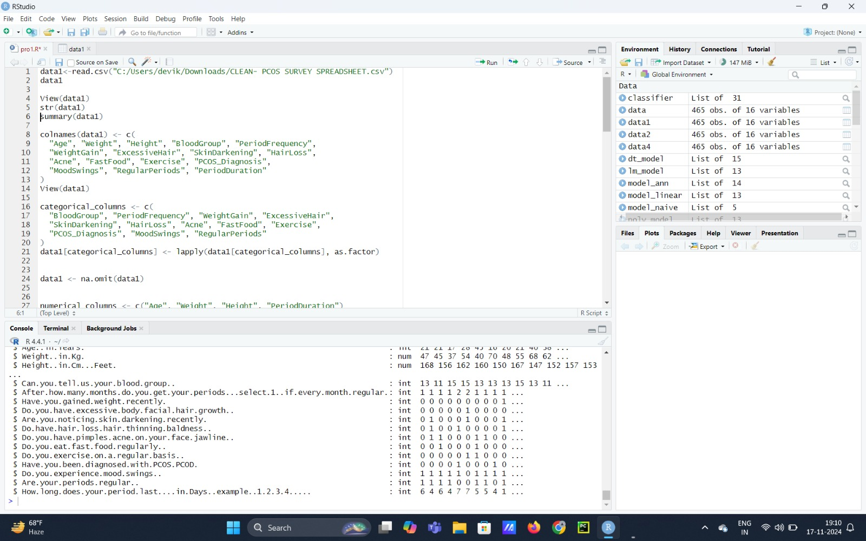

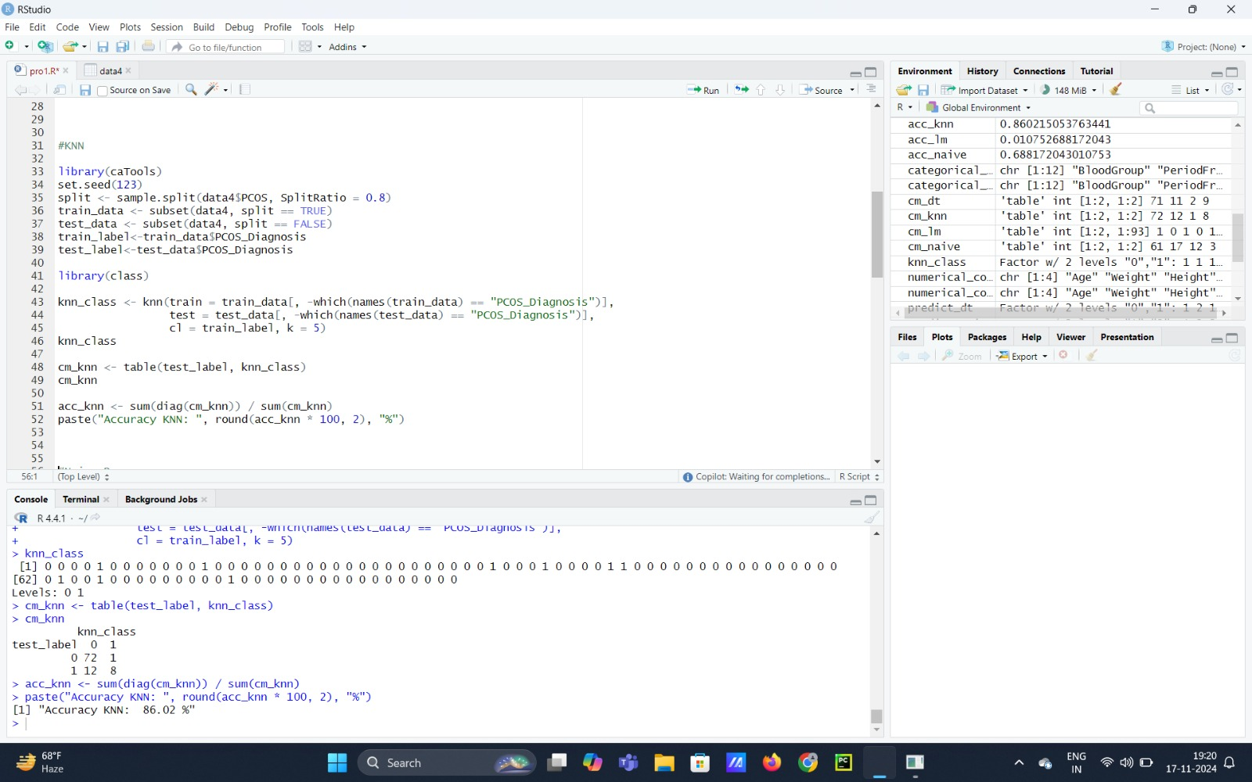

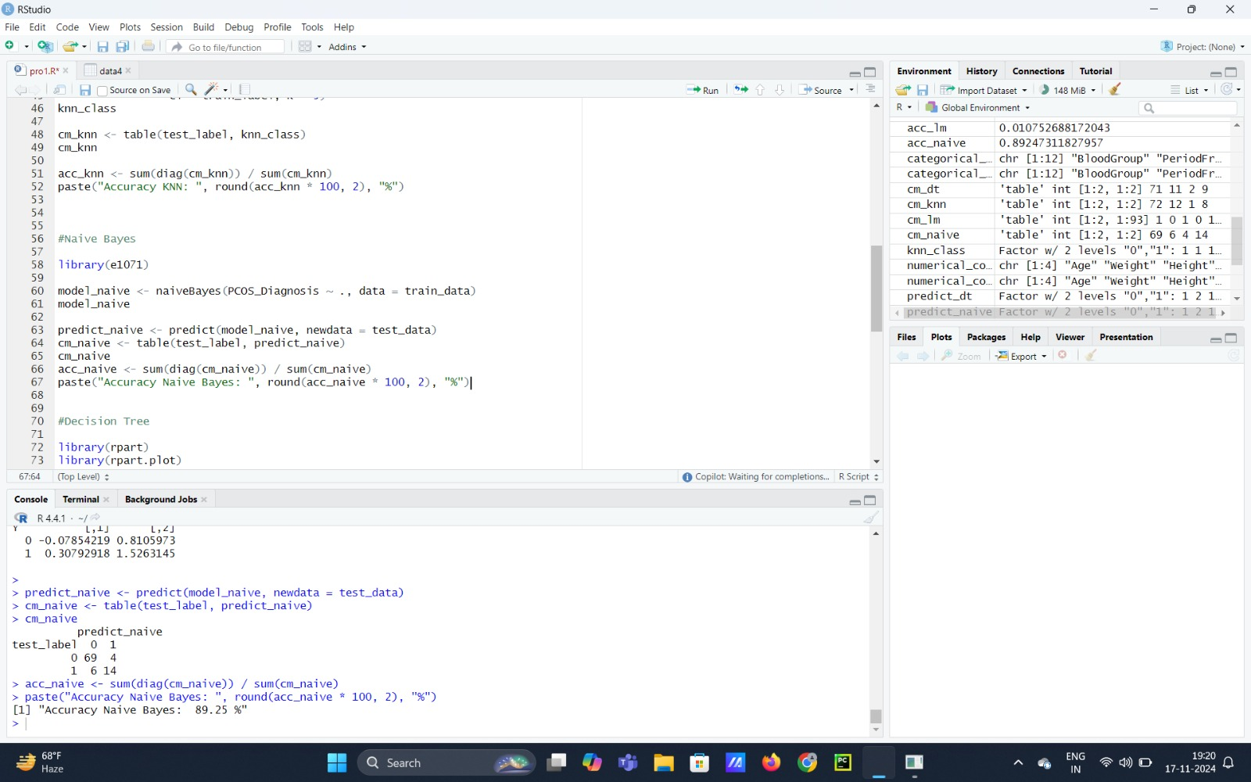

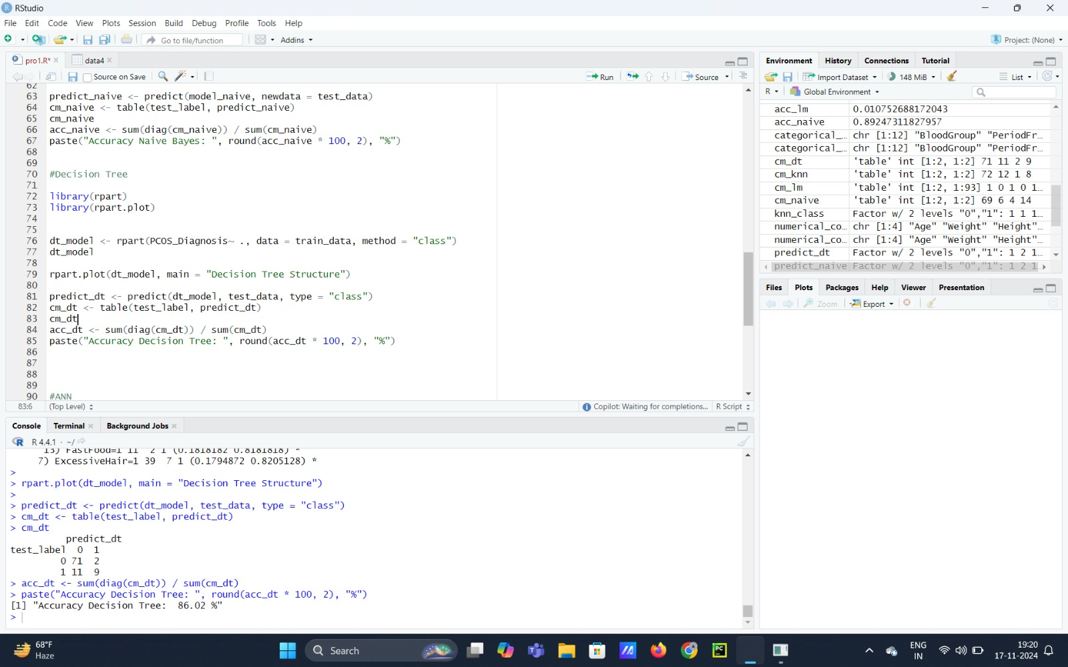

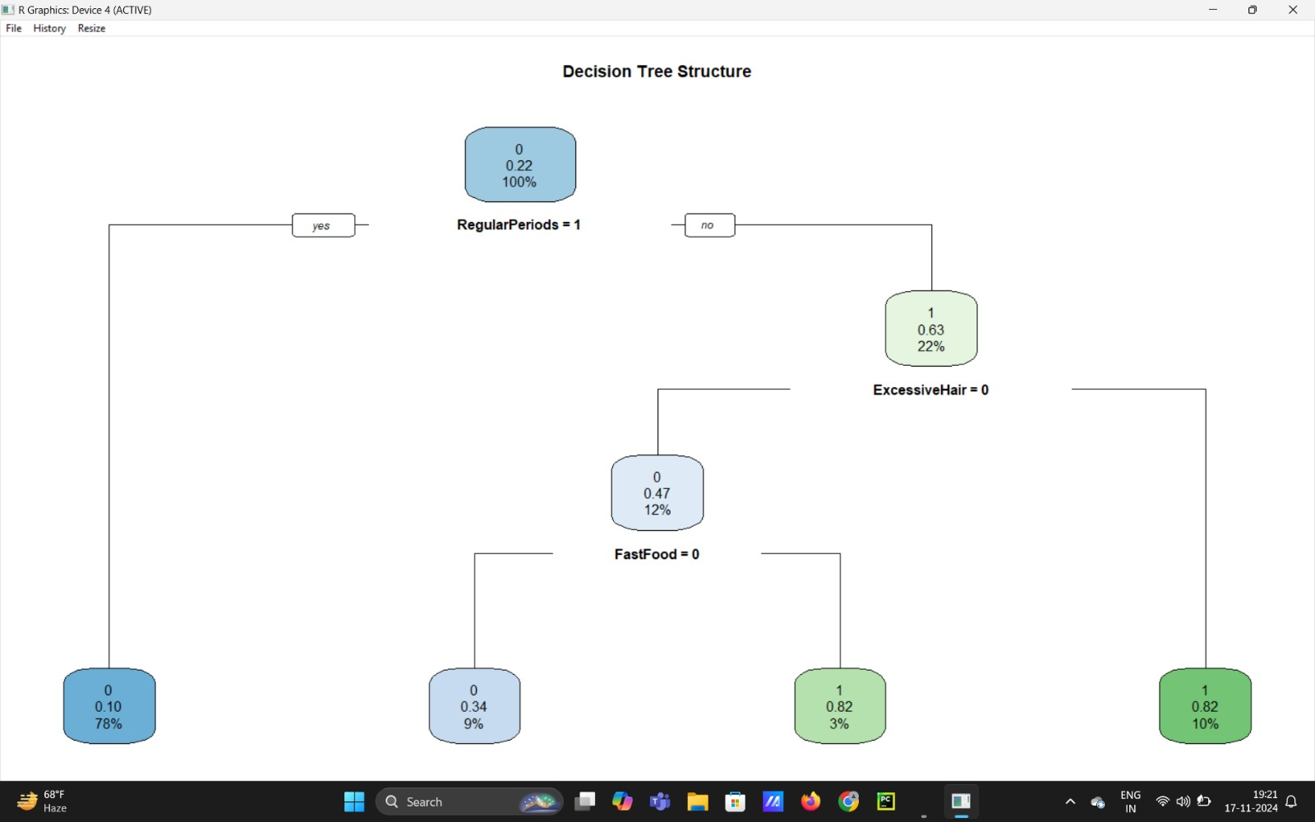

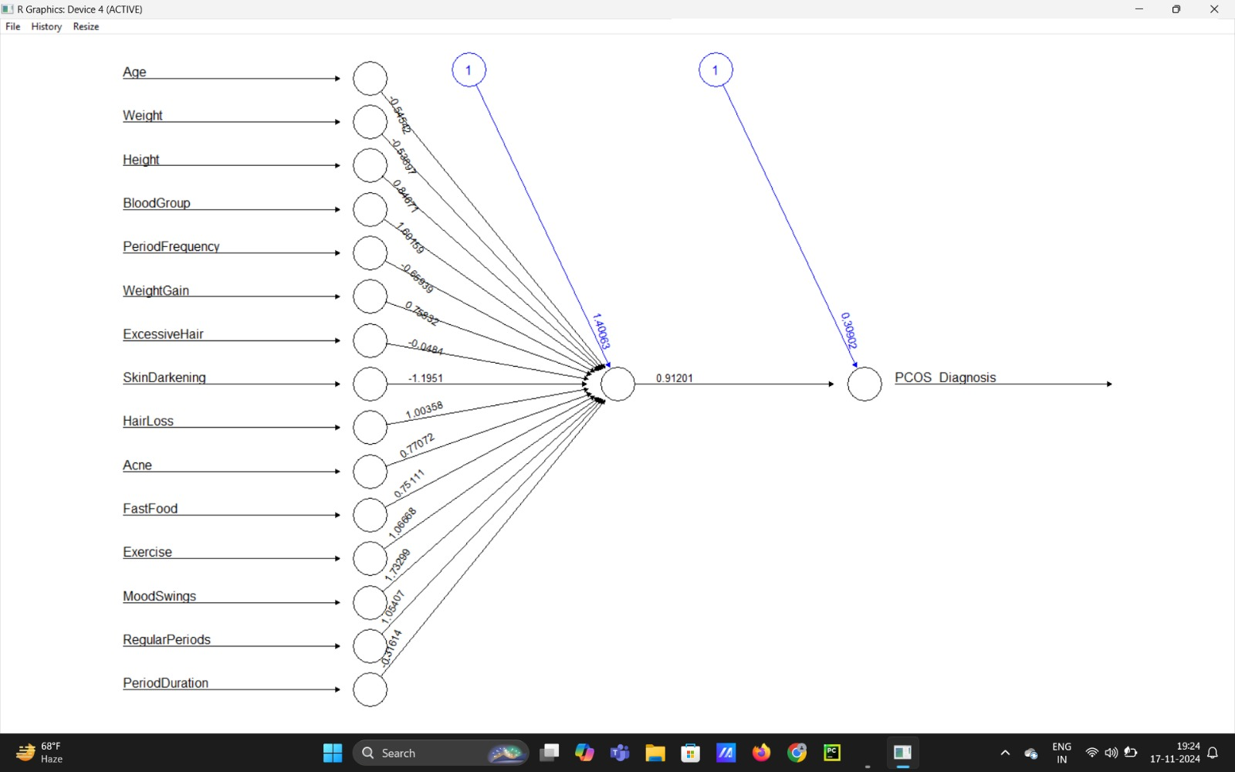
- List of Analysis with results
- Age and Weight Correlation:
The analysis revealed a strong correlation between age, weight, and the risk of PCOS. Women in higher weight categories (overweight or obese) were significantly more likely to be diagnosed with PCOS, particularly in the age range of 18-35 years. Younger women with higher BMI values showed an elevated likelihood of hormonal imbalances, which are key indicators of PCOS. This suggests that weight management, particularly during reproductive years, is a critical factor in mitigating PCOS risk.
- Lifestyle Analysis:
Lifestyle factors were assessed using indicators such as exercise frequency, dietary habits, and sleep patterns. The analysis highlighted the following:
Lack of Physical Activity: Women who reported minimal or no regular exercise had a noticeably higher prevalence of PCOS. Sedentary lifestyles correlated strongly with metabolic issues, such as insulin resistance, a known contributor to PCOS.
- High Fast Food Consumption: A diet high in processed foods, sugary beverages, and fast food was linked to increased PCOS risk. These dietary habits were associated with weight gain and hormonal irregularities, both of which exacerbate PCOS symptoms.
- Improvement Suggestions: Lifestyle modifications, including adopting a balanced diet and regular exercise routines, could serve as preventive measures and help in the management of PCOS.

- Diagnostic Accuracy
Multiple machine learning models were employed to predict PCOS based on the dataset’s health indicators. The models used included:
- Decision Trees : Offered improved prediction accuracy by handling complex relationships in the data effectively
- Artificial Neural Networks (ANN): Neural Networks demonstrated the best performance, achieving the highest diagnostic accuracy compared to other models. ANN’s ability to capture intricate patterns and interactions between features proved highly effective in distinguishing women with and without PCOS.

- Future scope
The future scope of this PCOS prediction project offers numerous opportunities for enhancement and practical implementation. Building on the success of Artificial Neural Networks (ANN), future iterations could focus on optimizing the neural network architecture to improve diagnostic accuracy further. Techniques like hyperparameter tuning, dropout layers, and batch normalization can enhance the model's robustness and predictive power, ensuring reliable results across diverse populations.
Another promising avenue is the integration of real-time data. Incorporating health data from wearable devices or health-tracking apps could provide continuous monitoring of parameters such as glucose levels, heart rate, and physical activity. This would enable the model to deliver real-time predictions and alerts for individuals at high risk, facilitating timely intervention and prevention. Additionally, the project can evolve into a personalized diagnostic tool by including more comprehensive datasets that capture genetic markers, family history, and detailed hormonal profiles. Such enhancements would allow for customized recommendations for lifestyle adjustments and treatment plans tailored to the unique needs of each individual.
The integration of this predictive model with electronic health record (EHR) systems used by healthcare providers would further its utility. During routine medical checkups, the system could automatically flag high-risk patients for further evaluation, enabling early screening and better management of PCOS. Furthermore, the development of a user-friendly mobile application could empower women to assess their PCOS risk, access educational resources, and track lifestyle habits. Real-time feedback and actionable insights from the app would encourage proactive health management and contribute to reducing the overall prevalence of PCOS.

- References
- Sir Notes
- https://www.youtube.com/watch?v=D_CNmYkGRUc
- https://www.youtube.com/watch?v=3iz-2iM4RFE

